**WORKSHEET 1**

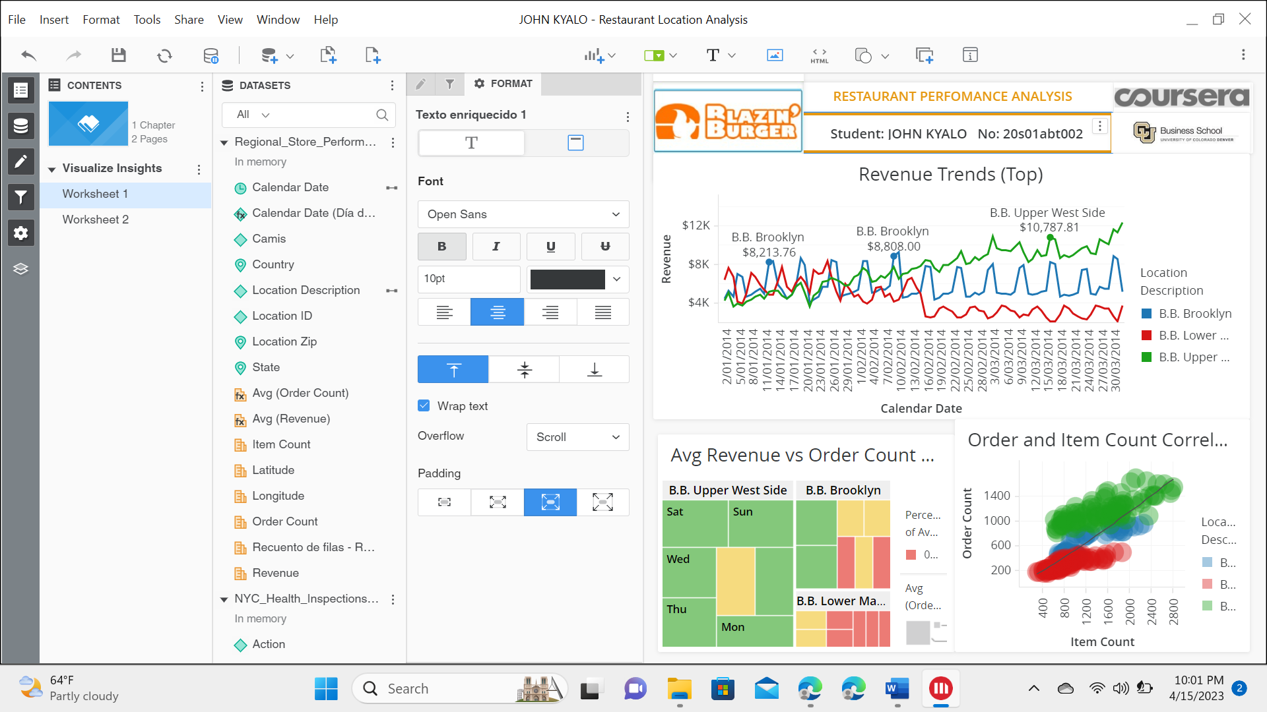

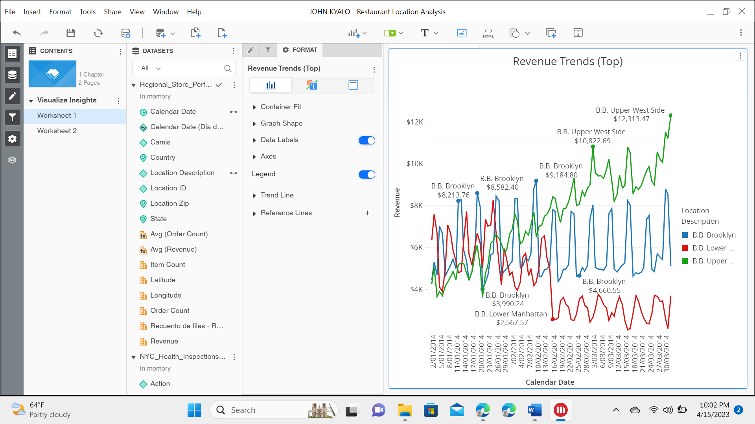

Revenues for all three locations were very similar until the Half of February. At this point: Brooklyn continued the same trajectory while Lower Manhattan fell significantly decreasing revenue and Upper West Side increased its earnings significantly.

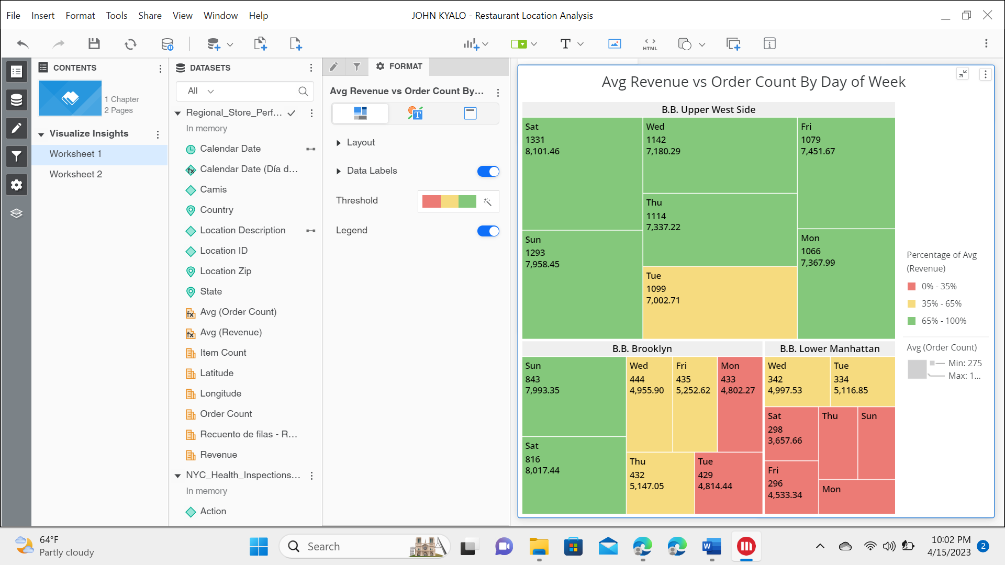

By Plotting the above HeatMap,we can observe the Avg(Order Count) and Avg(Revenue) at specific day and location, we can see that In Lower Manhattan, size or order count is least and has most light blue color (Least revenue) . It was red line in line chart before. This graph gives insight about order count at different locations and avg revenue which is same conclusion as before in line chart.

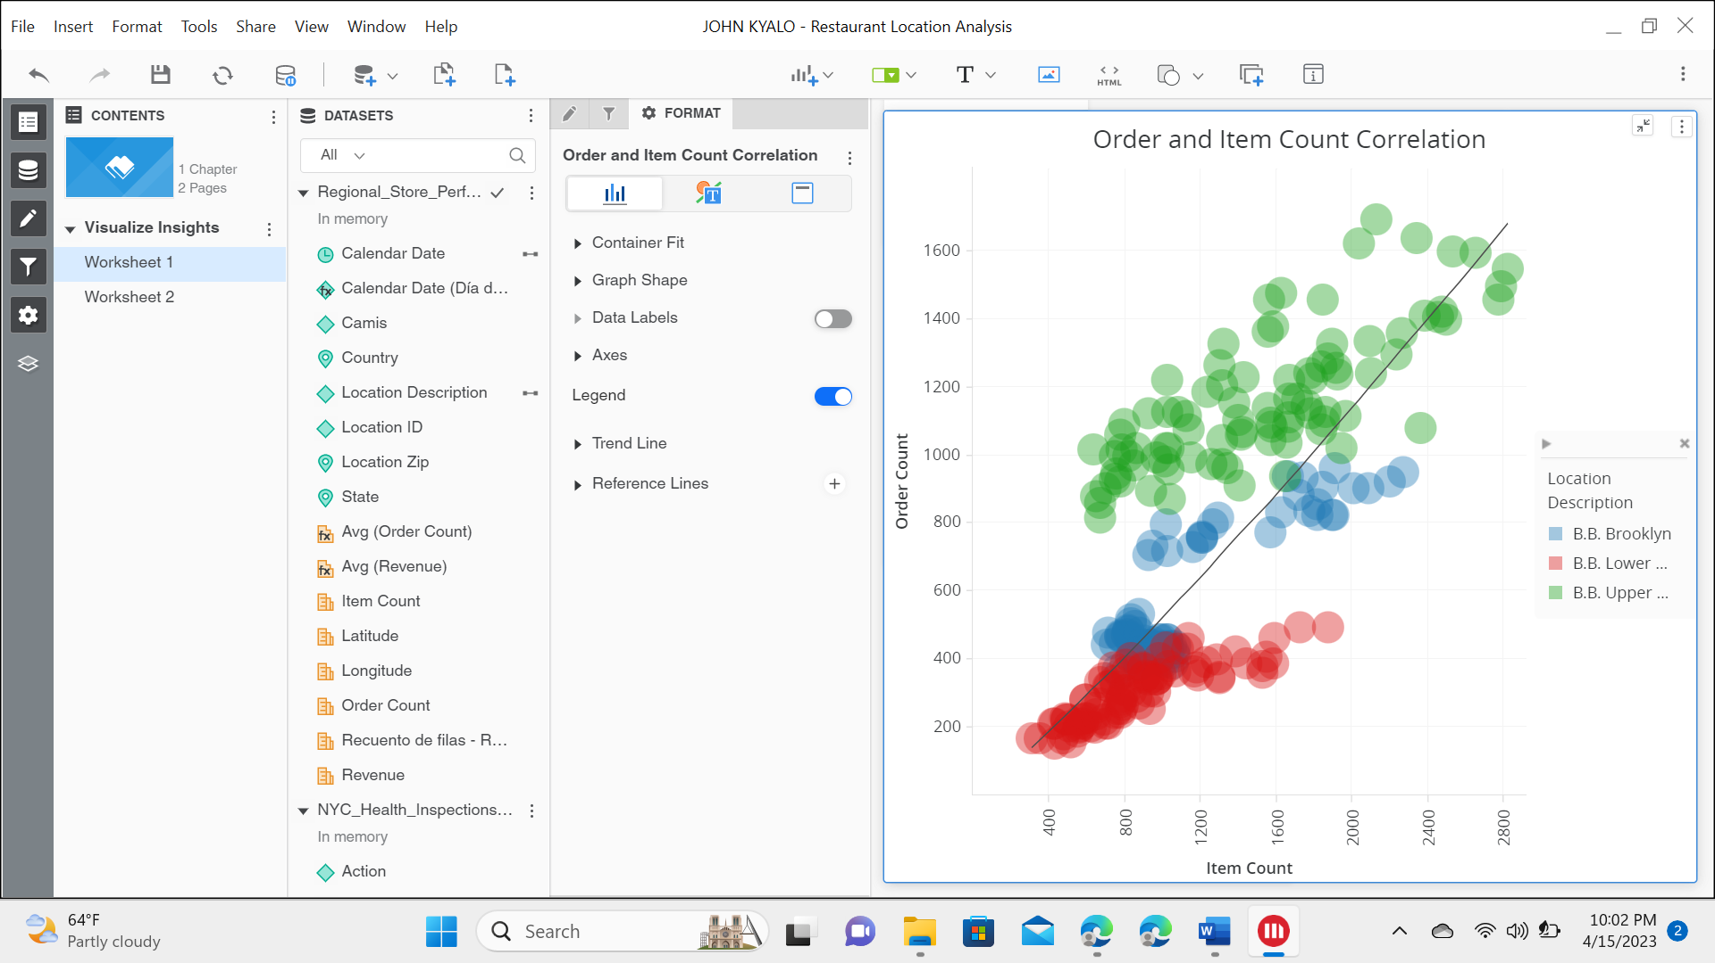

shows the correlation between the Order and item count. We can see a trend line along 45 degrees, Green color dots of Upper West Side are mostly above the Trend Line, that means almost always order count is above line in Upper West Side. Whereas Red color Lower Manhattan values are below the line always.

**WORKSHEET 2**

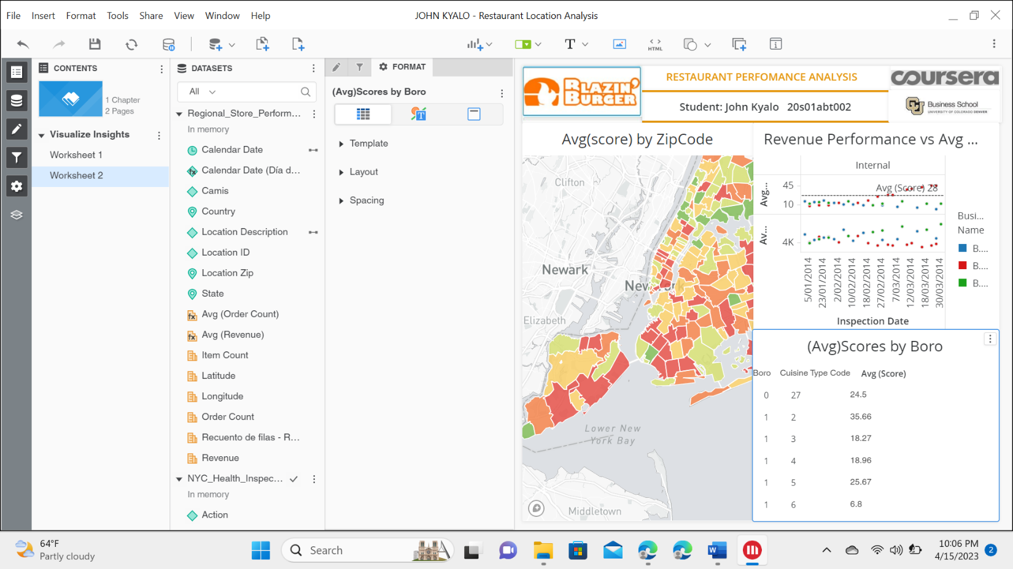

• Restaurant at B.B. Upper West Side is performing the best.

• Restaurant at B.B. Lower Manhattan is performing the worst.

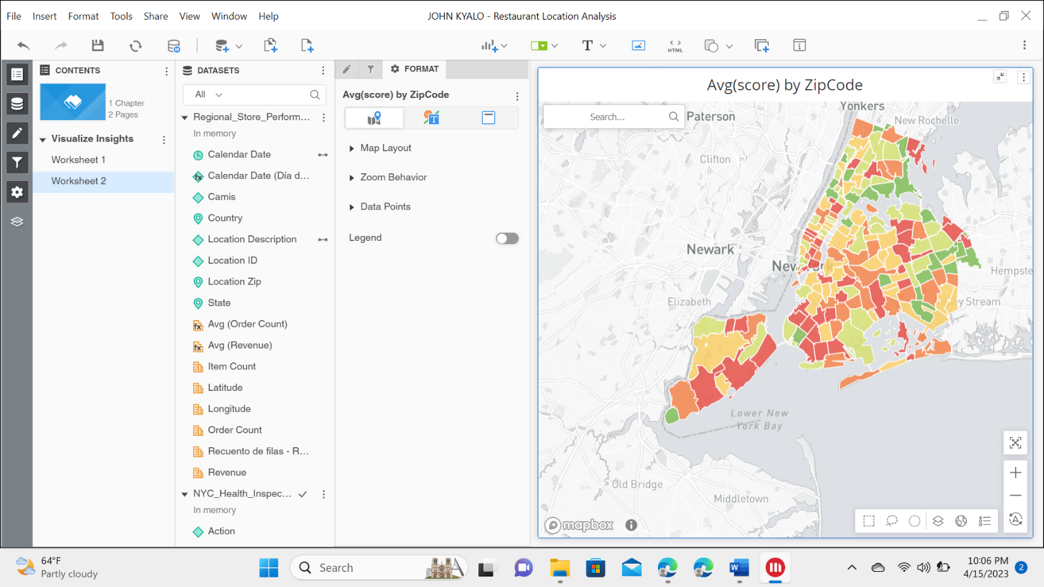

map by zip codes to get an overview of the regions. The color green has the lowest score and red has the highest scores; We can see more number of red patches than green ones indicating that overall most placements were rated well.



Avg(Score) is most for Red (Lower Manhattan) is correspondingly it has lowest revenue. Inpection above Reference Line of 28, receives C Grade and we see red dots are above that line. So higher scores is affecting the revenue.

